Stock Buddy

Final Report

Prepared by

Vince Recupito
PraveenKumar Elankovan
Mohammed Asim
Leonel Zuniga

Group 2 - Spring 2014

Table of Contents
I Project Description 9
1 Project Overview 9
2 The Purpose of the Project 9
2.a The User Business or Background of the Project Effort 9
2.b Goals of the Project 9
2.c Measurement 10
3 The Scope of the Work 10
3.a The Current Situation 10
3.b The Context of the Work 10
3.c Work Partitioning 10
3.d Competing Products 11
4 The Scope of the Product 11
4.a Scenario Diagram(s) 12
4.b Product Scenario List 12
4.c Individual Product Scenarios 13
5 Stakeholders 15
5.a The Client 15
5.b The Customer 15
5.c Hands-On Users of the Product 15
5.d Priorities Assigned to Users 15
5.e User Participation 15
5.f Maintenance Users and Service Technicians 16
5.g Other Stakeholders 16
6 Mandated Constraints 16
6.a Solution Constraints 16
6.b Implementation Environment of the Current System 16
6.c Partner or Collaborative Applications 16
6.d Off-the-Shelf Software 17
6.e Anticipated Workplace Environment 17
6.f Schedule Constraints 17
6.g Budget Constraints 17
7 Naming Conventions and Definitions 17
7.a Definitions of Key Terms 17
7.b UML and Other Notation Used in This Document 19
7.c Data Dictionary for Any Included Models 19
8 Relevant Facts and Assumptions 19
8.a Facts 19
8.b Assumptions 19
II Requirements 20
1 Product Use Cases 20
1.a. Use Case Diagrams 20
1.b Product Use Case List 20
1.c Individual Product Use Cases 21
2 Functional Requirements 25
3 Data Requirements 28
4 Performance Requirements 28
4.a Speed and Latency Requirements 28
4.b Precision or Accuracy Requirements 29
4.c Capacity Requirements 31
5 Dependability Requirements 32
5.a Reliability Requirements 32
5.b Availability Requirements 33
5.c Robustness or Fault-Tolerance Requirements 33
6 Maintainability and Supportability Requirements 34
6.a Maintenance Requirements 34
6.b Supportability Requirements 34
6.c Adaptability Requirements 35
6.d Scalability or Extensibility Requirements 36
6.e Longevity Requirements 37
7 Security Requirements 37
7.a Access Requirements 37
7.b Integrity Requirements 39
7.c Privacy Requirements 40
7.d Immunity Requirements 40
8 Usability and Humanity Requirements 41
8.a Ease of Use Requirements 41
8.b Personalization and Internationalization Requirements 42
8.c Learning Requirements 43
8.d Understandability and Politeness Requirements 43
8.e Accessibility Requirements 44
8.f User Documentation Requirements 45
8.g Training Requirements 46
9 Look and Feel Requirements 46
9.a Appearance Requirements 46
9.b Style Requirements 47
10 Operational and Environmental Requirements 49
10.a Expected Physical Environment 49
10.b Requirements for Interfacing with Adjacent Systems 49
10.c Productization Requirements 50
10.d Release Requirements 51
11 Cultural and Political Requirements 52
11.a Cultural Requirements 52
11.b Political Requirements 53
12 Legal Requirements 54
12.a Compliance Requirements 54
12.b. Standards Requirements 55
III Design 57
1. System Design 57
1.a Design goals 57
2. Current Software Architecture 58
3. Proposed Software Architecture 58
3.a Overview 58
3.b Class Diagrams 59
3.c Dynamic Model 61
3.d Subsystem Decomposition 66
3.e Hardware / software mapping 67
3.f Persistent Data management 67
3.g Access control and security 68
3.h Global software control 68
3.i Boundary conditions 68
4. Subsystem services 68
5. User Interface 70
6. Object Design 72
6.a Object Design trade-offs 72
6.b Interface Documentation guidelines 73
6.c Packages 73
6.d Class Interfaces 75
IV Test Plans 79
1 Features to be tested / not to be tested 79
2 Pass/Fail Criteria 79
3 Approach 79
4 Suspension and resumption 80
5 Testing materials ( hardware / software requirements ) 80
6 Test cases 80
7 Testing schedule 86
V Project Issues 87
1 Open Issues 87
2 Off-the-Shelf Solutions 87
2.a Ready-Made Products 87
2.b Reusable Components 87
2.c Products That Can Be Copied 87
3 New Problems 87
3.a Effects on the Current Environment 87
3.b Effects on the Installed Systems 88
3.c Potential User Problems 88
3.d Limitations in the Anticipated Implementation Environment That May Inhibit the new Product 88
3.e Follow-Up Problems 88
4 Tasks 88
4.a Project Planning 88
4.b Planning of the Development Phases 89
5 Migration to the New Product 89
5.a Requirements for Migration to the New Product 89
5.b Data That Has to Be Modified or Translated for the New System 89
6 Risks 90
7 Costs 90
8 Waiting Room 91
9 Project Retrospective 92
VI Glossary 93
VII References / Bibliography 94

List of Figures

Figure 1 : Scenario Diagram 12
Figure 2: User Scenario - Signup/Login 13
Figure 3: User Scenario – CheckingInterestedCompanyInfo 13
Figure 4: User Scenario – AddingWatchList 13
Figure 5: User Scenario – SuggestedCompaniesForInvestment 14
Figure 6: User Scenario – ReportingWebsiteIssues 14
Figure 7: User Scenario – TrackRecordOfOwnedShares 14
Figure 8: Use case Diagram 20
Figure 9: Data Requirments 28
Figure 10: Class Diagram - Main 59
Figure 11: ClassDiagram- System 60
Figure 12: Sequence Diagram- Login 61
Figure 13: Sequence Diagram - View Portfolio 62
Figure 14: Sequence Diagram- View WatchList 63
Figure 15: Sequence Diagram- EditGUI 63
Figure 16: Sequence Diagram- Set WatchList 64
Figure 17: Sequence Diagram- OpenAccount 64
Figure 18: Sequence Diagram- PlaceTrade 65
Figure 19: Sequence Diagram- GetRecommendation 65
Figure 20: Subsystem Decomposition 66
Figure 21: Hardware/Software Mapping 67
Figure 22: Persistent Data Management 68
Figure 23: Sample UI- Login_Page 70
Figure 24: Sample UI- Login_page_Failed_Login 70
Figure 25: Sample UI - Holdings 71
Figure 26: Sample UI- User_Profile 71
Figure 27: Sample UI- ViewWatchList 72
Figure 28: Sample UI- Set_WatchList 72
Figure 29: Package Diagram 74

List of Tables

Table 1 : List of Business events 10
Table 2 : Actors 11
Table 3 : Interface Documentation guidelines 73
Table 4 : Class Interface - Trader 75
Table 5 : Class Interface - WatchList 76
Table 6 : Class Interface - Recommendation 76
Table 7 : Class Interface - Preference 76
Table 8 : Class Interface - Portfolio 77
Table 9 : Class Interface - Trade 77
Table 10: Class Interface - Account 78
Table 11: Unit Testing 80
Table 12: Integration Testing 82
Table 13: System Testing 86
Table 14: Testing Schedule 86
Table 15: Project Planning 88
Table 16: Development Phase Planning 89
Table 17: Risks 90

Project Description

Project Overview
“StockBuddy” is a strategic tool for the trade lovers which allow you to watch over a set of company’s shares. It also lets you know how much one has lost or gained over a period of time when you possess a particular stock. It also suggests a set of companies that you could invest on depending on the range of the share price you are willing to afford. It allows you to print the statements and reports online, add preference to your profile, add organization’s share to watch out for, and look for the history of the shares you brought till the date.
The main objective of the “StockBuddy” is to ease the efforts of the user to check the market’s database daily. Instead, one can add those organizations’ name to the watch list and check for it once he logins. The element of security becomes an important factor to be handled as the application contains data regarding the possession of shares of the user in the companies. All the features are presented to the user with at most security.
The major advantage the project has is availability as a user can access it anywhere with internet access.
Another functionality is that one can enter the details of his/her possession and can keep track of all of those shares in a single profile. There is lot of data that has to be tracked down when one is involved in trading. This application will fulfill all those difficulties and ease the efforts of the user.

The Purpose of the Project

2.a The User Business or Background of the Project Effort
With the tool, one can have all the company’s shares information in one place. The motivation is to develop a computerized version of a traditional account book where one used to write all those information on the shares daily. This is a serious problem as there are trading tools which allows users to keep track of the shares that are only in their possession. This tool enables the users to keep track of all those company’s shares that he/she watches closely as well.

2.b Goals of the Project
We would like to create a product that can assist the traders and potentially become successful over the internet. It can be introduced as a mobile application and marketed and popularized over the smartphone app-market. The application is designed in such a way that it is simple and at the same time powerful enough to assist all of the traders irrespective of the fact whether they are novice or experts.

2.c Measurement
We can measure the aforementioned goals by the number of downloads and ratings received from customers. At the same time the goals can be measured by the number of returning users, as they are the ones who are satisfied in their previous working experiences with the application.

The Scope of the Work

3.a The Current Situation
Currently, there are many tools in the market associated with a brokerage firm. But those let the users look at the details of the shares that are already bought. Let us consider a beginner who watches out few companies’ shares. One way he has to do it is to look for the share details in a share market engine, one company at a time for multiple companies and if he has to do the same for the next day he has to repeat the same process. The proposed tool allows the users to look at the details of the company’s shares and he/she has the option to add the company to his/her preference and he/she does not have to repeat the process daily. Instead, one can login into their account and look the details of the already selected company’s shares.

3.b The Context of the Work
We need to investigate the current status of the tools that are available in the market. To build this product, one has to investigate how efficient the third party database can get updated with accordance to the server of the stock exchange. One has to also investigate how much load the server can handle without causing any crash.

3.c Work Partitioning

Event Name | Input and Output | Summary
Track user growth | Users tracked(I)  Low growth(O) | Track user growth and if its slow, certain promotional strategies may be applied like e-mail and social media.
Track user activity | Activity tracked(I)  Low activity(O) | Track user activity, and if its low, certain strategies like a weekly newsletter or a blog.
Track server health | Server health tracked(I)  Current servers unable to handle load(O) | Track server health, and if more are needed, install them.
Track user satisfaction | User feedback received(I) | Ask for feedbacks from the users once in a while and look to improve on their comments.
Track competitors | Competitors tracked(I)  New features added(O) | Track the competitor’s tool and if there is a new feature and if it so worth of implementing, plan and develop.

Table 1: List of business events

3.d Competing Products
The primary competing entities would be trading applications sponsored by the stock brokering sites. As discussed before, they are perfect in their own right but our product introduces a unique concept where even those who have not brought the shares can have a watch over them and one can have a watch over multiple companies along with keeping track of the already bought shares. There is a need of having an huge server with an huge database that can collectively process requests of the users without any latency and hence provide a good user experience.

The Scope of the Product
Actors:
Name | Description
Trader | Making use of website data in buying and selling of shares.
Website Admin | Maintaining the websites issues like browser compatibilities, answering various queries on generic website issues.
Brokerage Firm | The authority providing credential for the customers/traders to be able to use the website facilities.
Third Party Data | Acting as a source of various companies data for the website.
Table 2: Actors

4.a Scenario Diagram(s)
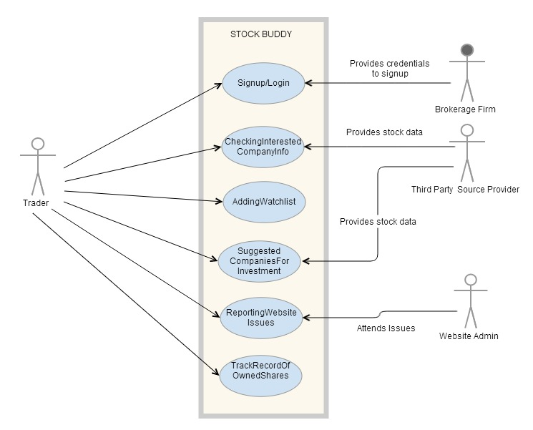
Figure 1 : Scenario Diagram

4.b Product Scenario List
Figure 4.2: User Scenario - Signup/Login
Figure 4.3: User Scenario - CheckingInterestedCompanyInfo
Figure 4.4: User Scenario - AddingWatchList
Figure 4.5: User Scenario - SuggestedCompaniesForInvestment
Figure 4.6: User Scenario - ReportingWebsiteIssues
Figure 4.7: User Scenario - TrackRecordOfOwnedShares

4.c Individual Product Scenarios

Individual Product Scenarios

Scenario name | SignUp/Login
Participating Actor | Billy: Trader
Precondition(s) | 1) Billy has the unique Id provided by brokerage firm.
Flow of Events | 1) Billy visits the StockBuddy website for the first time.  2) StockBuddy presents login/signup page.  3) Billy sign up by creating a new account by filling required form details.  4) StockBuddy provides the user name and password to Billy.  5) Billy enters login credentials on re-login.  6) StockBuddy displays the main menu page of the website on successful login.
Figure 2: User Scenario - SignUp/Login
Scenario name | CheckingInterestedCompanyInfo
Participating Actor | Billy: Trader
Precondition(s) | 1) Billy has already logged in.  2) Billy is on the main menu page.
Flow of Events | 1) Billy selects a company.  2) StockBuddy shows the stock details of the selected company.
Figure 3: User Scenario – CheckingInterestedCompanyInfo
Scenario name | AddingWatchList
Participating Actor | Billy: Trader
Precondition(s) | 1) Billy has already logged in.  2) Billy is on the main menu page.
Flow of Events | 1) Billy selects a company.  2) StockBuddy shows the stock details of the selected company  3) Billy adds the company to his favorite list by clicking on “AddToFavorite” option.  4) StockBuddy saves the company in watchlist
Figure 4: User Scenario – AddingWatchList
Scenario name | SuggestedCompaniesForInvestment
Participating Actor | Billy: Trader
Precondition(s) | 1) Billy has already logged in.  2) Billy is on the main menu page.
Flow of Events | 1) Billy requests for suggestion.  2) StockBuddy opens up a form asking for priorities (share value range) and other preferences.  3) Billy fills the form and submits it to the system.  4) StockBuddy lists the companies.
Figure 5: User Scenario – SuggestedCompaniesForInvestment
Scenario name | ReportingWebsiteIssues
Participating Actor | Billy: Trader, James: Admin
Precondition(s) | 1) Billy has already logged in.  2) Billy is on the main menu page.
Flow of Events | 1) Billy reports an issue to StockBuddy.  2) Stockuddy forwards the issue to James.  3) James receives the reported issue and resolves it.  4) Billy receives an acknowledgement of the same.

Figure 6: User Scenario - ReportingWebsiteIssues
Scenario name | TrackRecordOfOwnedShares
Participating Actor | Billy: Trader
Precondition(s) | 1) Billy has already logged in.  2) Billy is on the main menu page.
Flow of Events | 1) Billy clicks on Holdings option.  2) StockBuddy opens the empty page to add the share holdings details.  3) Billy enters his all owned shares information and submits to StockBuddy.  4) StockBuddy lists the information entered by Billy.

Figure 7: User Scenario - TrackRecordOfOwnedShares

Stakeholders

5.a The Client
The client will be a brokerage firm looking to provide this software for use to their own customers.

5.b The Customer
The customer is the same as the client.

5.c Hands-On Users of the Product
The hands-on users of the product will be the client’s own customers. This software will be provided free of charge from their broker as an investment tool. More generally, these users will be traders and retail investors. The users are not obligated to use the investment tool and they are free to use the tool in any manner they wish while still abiding by the broker’s terms of use. The user may be a novice, professional, or anywhere in between. The user may or may not have a similar investment tool from other brokers or investment companies. The users will either be using this tool for their company’s trades, and/or their own trades. They will have an understanding of basic terms of the trading industry. Statistically, these users will most likely be middle or upper class.

5.d Priorities Assigned to Users
The key users of this product will be active traders. These are the users who will use the software daily, make two hundred or more trades per year, and rely on the product to maximize their own profits.
The secondary users of this product will be inactive traders. These are the users who may not
use the product daily, may not make more than two hundred trades per year, and may not rely on the product to maximize their own profits.
The unimportant users are those that are not authorized to use the product. These users may have obtained an illegal copy of the program or are not registered clients of the broker providing the software.

5.e User Participation
User participation is moderately important to the success of the project. Users will provide what they think should be included in the project as they know what tools they need most to analyze equity positions. A brief meeting with the users is necessary to establish what they think should be included in the final project.

5.f Maintenance Users and Service Technicians
They are no maintenance users of the product.

5.g Other Stakeholders
Additional stakeholders include competing brokerage firms who don’t provide the product, competing traders who don’t have access to the product, and publicly traded companies whose equity value may be altered by the traders using this product.
These are all negative stakeholders in the project. They need no knowledge of the project, have no involvement in the project, but may be negatively affected by the product.

Mandated Constraints

6.a Solution Constraints
The product should be stand-alone executable which will have access to the web for the relevant that the trader is looking for. The product will grab the data from the online resource and then manipulate it to give the trader the information he was looking for. The computer on which the product is running on must have online access in order for the product to access the online information. The product will be able to deliver information more efficiently than the current online resources available.

6.b Implementation Environment of the Current System
The environment in which the product will be installed will be on a trader's computer. Whether it’s a work or at home the product should work the same. The product should run efficiently and not process intensive. This will allow the product to run on variety of systems and the trader would not have to worry about whether or not the computer is able to run the product. The product should run on at least windows.

6.c Partner or Collaborative Applications
This product will retrieve data from an online source. The online data will then be returned and interpreted into useful data for the trader. The product must have access to the online data source. If the source is not there then the product will not work. One thing we can do is to have back up sources to this source. The online resource for the data must be available in order for the product to work. Additionally the product must also have online access in order to access the online resource. We can investigate other online data resources to use in case our primary one is unavailable.

6.d Off-the-Shelf Software
This product is a standalone application. The online resource it needs is the only other software requirement that this product needs. The online data source must work with our product. It is where our product is retrieving all the data the the trader requested.

6.e Anticipated Workplace Environment
The workplace environment would be anywhere the trader finds himself trading. This could be a variety of places but would most likely be home and work. Therefore the product interface should be neat and simple and clean. This would put the information as the center of focus for the interface. As long as the trader is an area where he has online access than the product should work as expected. At the time there is work environment constrains other than the work environment have online access.

6.f Schedule Constraints
The deadline would be 16 weeks after the start day. This gives the developers time to get everything working properly and have the interface looking clean. After the first scenario. The program should be able to grab the data from the online resource and process it accordingly without an interface. After the second one the interface should be designed to display the data. The product should be done 16 weeks after the start day with key components done in between those days. The product can be offered to traders as an extra tool to help them become better traders.

6.g Budget Constraints
The budget for this product is four software developers for sixteen weeks. The product can be built within that time and the benefits the trader will receive outweigh the cost. The trader will be able to make more trades more efficiently and therefore a greater profit for them which in turn will cause the trader to tell other people about this tool which in turn will bring us more customers to our firm.

Naming Conventions and Definitions

7.a Definitions of Key Terms
Ask: The lowest price a seller of a stock is willing to take for a share of that given stock
Beta: The tendency of a security’s return to respond to swings in the overall market
Bid: The highest price a buyer of a stock is willing to pay for a share of that given stock
Close: The last sale price of a stock on any particular day
Dividend: A sum of money paid regularly by a company to its shareholders out of its profits
Dividend Yield: A dividend expressed as a percentage of a current share price
Earnings date: The date that a particular company will make public its financial reports for the previous quarter.
Earnings per Share (EPS): The portion of a company’s profit allocated to each outstanding share of common stock.
High: The highest price a particular stock traded for in a given day
Last: The price of the most recent trade of a particular stock.
Low: The lowest price a particular stock traded for in a given day
Open: The first sale price of a stock on any particular trading day
Market Capitalization (Market Cap): The total dollar market value of all a company’s outstanding shares
Net Change: The difference in the closing price of the previous trading day and the last price of a particular stock.
Paper: A simulation with regards to stock trading
Price to Earnings (P/E): The contraction of a stock’s price to earnings ratio
Quote: A detailed list of information on a stock.
Stock: The generic term for common equity securities
Stock Exchange: A market in which securities are bought and sold
Symbol: Abbreviation used to uniquely identify publicly traded shares of a particular stock on a particular stock exchange
Trader: Someone who buys and sells equities
Volume: The number of shares that have been traded for a particular stock in a particular trading day.
Watchlist: A list of stocks that a trader is interested in.
For a complete listing of terms, see the glossary on page 93.

7.b UML and Other Notation Used in This Document
This document generally follows the Version 2.3 OMG UML standard. Any exceptions are noted where used.

7.c Data Dictionary for Any Included Models
There currently are no dictionary definitions of information flows and stores used in the models.

Relevant Facts and Assumptions

8.a Facts
Stocks may be listed in more than one exchange. Most stock exchanges are open for trading during normal business hours during business days.

8.b Assumptions
Due to the nature of the product, users will mostly use the product during trading hours. Off-peak usage will occur during nights and weekends which are suitable for software patches.

Requirements

Product Use Cases

1.a. Use Case Diagrams

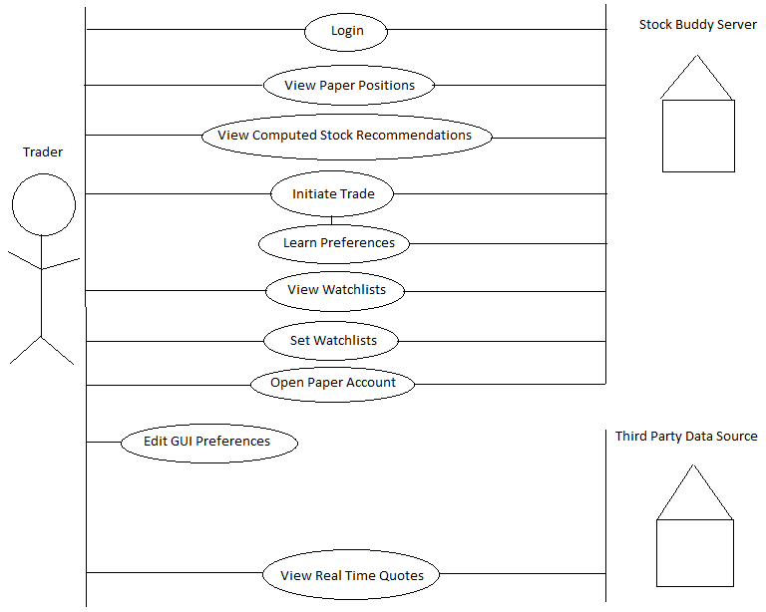
Figure 8: Use case Diagram

1.b Product Use Case List
- Login
- View Paper Positions
- View Computed Stock Recommendations
- View Watchlists
- Set Watchlists
- View Real Time Stock Quote
- Initiate Paper Trade
- Edit GUI Preferences
- Learn Preferences
- Update Real Time Quotes
- Open Paper Account

1.c Individual Product Use Cases
Use Case Name: Login
Participating Actors: Trader, Stock Buddy
Flow of Events:
- The trader enters in his user-name and password on the welcome page, and clicks “Login”.
- Stock Buddy presents “Stand By” message and checks authorization.
- Stock Buddy either accepts or denies the request. If accept, Stock Buddy transfers the Trader to the home page. If denied, Stock Buddy sends an error message to the Trader.
Entry Conditions: Trader is on the welcome page.
Exit Conditions: Trader has received accept or deny request and is on home page.

Use Case Name: View Paper Positions
Participating Actors: Trader, Stock Buddy
Flow of Events:
- The Trader clicks on “View Paper Positions” on the home page.
- Stock Buddy responds by presenting the “Paper Positions” page.
Entry Conditions: Trader is on the home page.
Exit Conditions: Trader is on the “Paper Positions” page.

Use Case Name: View Computed Stock Recommendations
Participating Actors: Trader, Stock Buddy
Flow of Events:
- Trader clicks on “View Computed Stock Recommendations” on the home page.
- Stock Buddy responds by presenting the “Computed Stock Recommendations” page.
Entry Conditions: Trader is on the home page.
Exit Conditions: Trader is on the “Computed Stock Recommendations” page.

Use Case Name: View Watchlists
Participating Actors: Trader, Stock Buddy
Flow of Events:
- Trader clicks on “View Watchlists” on the home page.
- Stock Buddy responds by presenting the “Watchlists” page.
Entry Conditions: Trader is on the home page.
Exit Conditions: Trader is on the “Watchlists” page.

Use Case Name: Set Watchlists
Participating Actors: Trader, Stock Buddy
Flow of Events:
- Trader clicks on “Set Watchlists” on the home page.
- Stock Buddy responds by presenting the “Set Watchlists” page.
- Trader enters in a list of stocks to add to the watchlist.
- Stock Buddy responds by adding the list of stocks to the watchlist and returns Trader to the home page.
Entry Conditions: Trader is on the home page.
Exit Conditions: Trader is on the home page with stocks added to watchlist.

Use Case Name: View Real Time Stock Quote
Participating Actors: Trader, Third Party Data Source
Flow of Events:
- Trader enters in symbol of stock in input box and clicks on “View Real Time Stock Quote” on the home page.
- Third Party Data Source responds by presenting the “Real Time Stock Quote” page showing detail information on the requested symbol.
Entry Conditions: Trader is on the home page.
Exit Conditions: Trader is on the detailed stock page showing information on a symbol.

Use Case Name: Initiate Paper Trade
Participating Actors: Trader, Stock Buddy
Flow of Events:
- Trader clicks on “Initiate Paper Trade” on the home page.
- Stock Buddy responds by presenting the “Initiate Paper Trade” page.
- Trader can enter in one stock and the details of the trade he/she wishes to places with that stock.
- Stock Buddy returns the Trader to the home page. Stock Buddy invokes the “Learn Preferences” Use case.
Entry Conditions: Trader is on the home page.
Exit Conditions: Trader is on the home page with the particular trade filled.
Use Case Name: Edit GUI Preferences
Participating Actors: Trader
Flow of Events:
Trader clicks on “Edit GUI Preferences” on the home page. The trader can then edit various GUI preferences such as theme, font size, etc. This information is not persistent between logins and is therefore not saved to Stock Buddy’s Server.
Entry Conditions: Trader is on the home page.
Exit Conditions: Trader is on the home page.

Use Case Name: Learn Preferences
Participating Actors: N/A
Flow of Events:
Stock Buddy places stores initiated trade into storage and computes a new list of recommended stocks based on all initiated trades. Stock Buddy will recommend stocks trades that resemble previously executed trades regarding symbol and price.
Entry Conditions: “Initiate Paper Trade” use case invokes “Learn Preferences” use case.
Exit Conditions: Initiated trade is placed in storage and new list of recommended stocks is computed.

Use Case Name: Open Paper Account
Participating Actors: Trader, Stock Buddy
Flow of Events:
- Trader selects “Open Paper Account” from welcome page.
- Stock Buddy responds by presenting “Open Paper Account” page.
- Trader enters in relevant information along with user-name and password to Stock Buddy.
- Stock Buddy either approves or declines the application and shows result to the Trader.
Entry Conditions: Stock Buddy application is open.
Exit Conditions: Either a new account has been created or a message is displaying showing why the new account was denied.

Functional Requirements
Requirement #1
Description: The product must display stock details of a company upon getting a request from the user.
Originator: Vince Recupito
Fit Criterion: The user should be able to view the stock details of the requested company.
Customer Satisfaction: 3
Customer Dissatisfaction: 5
Priority: High
Created: February 20, 2014

Requirement #2
Description: The product shall display the list of companies marked favorite in the watchlist with the choice of viewing each of their stock details.
Originator: Vince Recupito
Fit Criterion: The user should be able to view the list of favourite companies in the watchlist.
Customer Satisfaction: 3
Customer Dissatisfaction: 5
Priority: High
Created: February 20, 2014

Requirement #3
Description: The product shall be able to place paper trades.
Originator: Vince Recupito
Fit Criterion: All requests to place paper trades get correctly filled.
Customer Satisfaction: 3
Customer Dissatisfaction: 5
Priority: High
Created: February 20, 2014

Requirement #4
Description: The product shall be able to recommend stocks to purchase based on previous trading history.
Originator: Vince Recupito
Fit Criterion: The product shall always have at least one stock to recommend if the user has placed at least one trade in the history of his/her account.
Customer Satisfaction: 3
Customer Dissatisfaction: 5
Priority: High
Created: February 20, 2014

Requirement #5
Description: The product shall be able to provide real time quote data from a third party data source.
Originator: Vince Recupito
Fit Criterion: The trader should always be seeing the most up-to-date stock quote information.
Customer Satisfaction: 3
Customer Dissatisfaction: 5
Priority: High
Created: February 20, 2014

Requirement #6
Description: The product shall be able to allow a trader to request to open a paper account with Stock Buddy.
Originator: Vince Recupito
Fit Criterion: All requests to open an account either get approved or declined.
Customer Satisfaction: 3
Customer Dissatisfaction: 5
Priority: High
Created: February 20, 2014

Data Requirements

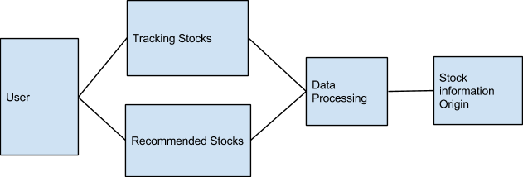

Figure 9: Data Requirements

Performance Requirements

4.a Speed and Latency Requirements
Requirement #1
Description: StockBuddy should grab and display the user requested stock information just as fast as if the user had gone online to an online source to grab the same information.
Originator: Leonel Zuniga
Fit Criterion: Stock Buddy should return the stock information just as fast as if the user had gotten it from an online source.
Customer Satisfaction: 3
Customer Dissatisfaction: 5
Priortity: High
Created: February 28, 2014

Requirement #2
Description: StockBuddy should give suggested stocks to buy to the user in a timely manner.
Originator: Leonel Zuniga
Fit Criterion: Stock Buddy should return suggested stocks to but in under 10 seconds.
Customer Satisfaction: 3
Customer Dissatisfaction: 5
Priority: High
Created: February 28, 2014

Requirement #3
Description: Stock Buddy should grab stock information as often as possible.
Originator: Leonel Zuniga
Fit Criterion: Stock Buddy should retrieve new stock information every 10 seconds..
Customer Satisfaction: 3
Customer Dissatisfaction: 5
Priority: High
Created: February 28, 2014

.

4.b Precision or Accuracy Requirements
Requirement #1
Description: The information of the stocks should be accurate to the available information online in order to keep the user as well informed as possible.
Originator: Leonel Zuniga
Fit Criterion: We can check the prices with various online sources to ensure our informations accuracy..
Customer Satisfaction: 3
Customer Dissatisfaction: 5
Priority: High
Created: February 28, 2014

Requirement #2
Description: The information should also be as kept updated on a constant basis. This will allow us to keep the user well informed with the most recent stock information.
Originator: Leonel Zuniga
Fit Criterion: Again we can check this by manually checking our new stock information against various stock information available online.
Customer Satisfaction: 3
Customer Dissatisfaction: 5
Priority: High
Created: February 28, 2014

Requirement #3
Description: The stock recommendation should also suggest companies that are relevant to the user’s interest. For example if the user shows plenty of interest in technology companies then it should suggest technology companies to buy.
Originator: Leonel Zuniga
Fit Criterion: We can check the prices with various online sources to ensure our informations accuracy..
Customer Satisfaction: 3
Customer Dissatisfaction: 5
Priority: High
Created: February 28, 2014

4.c Capacity Requirements
Requirement #1
Description: Stock Buddy should be able to keep stock information on as many as 50 different stocks. The average user will only care about the handful of stocks that they own or are interested in so 50 should be enough..
Originator: Leonel Zuniga
Fit Criterion: Stock Buddy should be able to retrieve the information of 50 different stocks.
Customer Satisfaction: 3
Customer Dissatisfaction: 5
Priority: High
Created: February 28, 2014

Requirement #2
Description: An upgrade that the user could purchase for a small fee will allow the user to keep track of as many as 500 different stocks.
Originator: Leonel Zuniga
Fit Criterion: After the upgrade, Stock Buddy should be able to keep track of up to 500 different stocks.
Customer Satisfaction: 3
Customer Dissatisfaction: 5
Priority: low
Created: February 28, 2014

Dependability Requirements

5.a Reliability Requirements
Requirement #1
Description: Stock Buddy should work properly as long as it has an internet connection so that it may grab the most recent stock information.If no internet connection is available then Stock Buddy should inform the user but still display the most recent stock information available.
Originator: Leonel Zuniga
Fit Criterion: Start up Stock Buddy with an internet connection and then disconnect it. Stock Buddy should display the last available stock information it retrieved.
Customer Satisfaction: 3
Customer Dissatisfaction: 5
Priority: High
Created: February 28, 2014

Requirement #2
Description: Stock Buddy should be able to properly keep track of 50 different stock and all their relevant information.
Originator: Leonel Zuniga
Fit Criterion: We assign Stock Buddy to keep track of 50 different stocks and see how it does.
Customer Satisfaction: 3
Customer Dissatisfaction: 5
Priority: High
Created: February 28, 2014

5.b Availability Requirements
Requirement #1
Description: Stock Buddy should be available to the user at all times of the day.
Originator: Leonel Zuniga
Fit Criterion: Stock Buddy should be available to the user at all times of the day. If new stock information is available then Stock Buddy should update its stock information. If no new stock information is available then Stock Buddy should display the most recent stock information.
Customer Satisfaction: 3
Customer Dissatisfaction: 5
Priority: High
Created: February 28, 2014

5.c Robustness or Fault-Tolerance Requirements
Requirement #1
Description: In order for Stock Buddy to operate properly it must have an internet connection so that it can get the most recent stock information.
Originator: Leonel Zuniga
Fit Criterion: If Stock Buddy does not have an internet connection than it will display the most recent stock information while informing the user that there is no internet connection.
Customer Satisfaction: 3
Customer Dissatisfaction: 5
Priority: High
Created: February 28, 2014

6 Maintainability and Supportability Requirements

6.a Maintenance Requirements
Requirement #1
Description: Maintenance works needs to be held in the non-working hours of stock market.
Originator: Mohammed Asim
Fit Criterion: The product shall be up and running as before the maintenance.
Customer Satisfaction: 3
Customer Dissatisfaction: 5
Priority: High
Created: March 11, 2014

6.b Supportability Requirements
Requirement #1
Description: The product must include a user guide acting as a self-learning resource.
Originator: Mohammed Asim
Fit Criterion: The user guide must be accessible containing the instructions to get started.
Customer Satisfaction: 5
Customer Dissatisfaction: 5
Priority: High
Created: March 11, 2014

Requirement #2
Description: This product must be easy to use for a trader with basic skills working on computer.
Originator: Mohammed Asim
Fit Criterion: The survey feedback must have “ease of use” average rating above 4 on a scale of 5 with 5 being the ‘strongly agree’.
Customer Satisfaction: 3
Customer Dissatisfaction: 3
Priority: Medium
Created: March 11, 2014

6.c Adaptability Requirements
Requirement #1
Description: The website must open in popular browsers like Internet Explorer,GoogleChrome and Mozilla Firefox etc.
Originator: Mohammed Asim
Fit Criterion: The trader shall be able to work smoothly on the various browsers .
Customer Satisfaction: 5
Customer Dissatisfaction: 3
Priority: Medium
Created: March 11, 2014

Requirement #2
Description: This product must be compatible for Mobile phones, tablets along with personal computers and laptops.
Originator: Mohammed Asim
Fit Criterion: The trader shall be able to open the website on Mobile phones, tablets and personal computers.
Customer Satisfaction: 3
Customer Dissatisfaction: 3
Priority: Medium
Created: March 1.1, 2014

6.d Scalability or Extensibility Requirements
Requirement #1
Description: This product must be able to handle 10,000 customers and around 40,000 customers in next 3 years.
Originator: Mohammed Asim
Fit Criterion: The trader shall be able to get the requested stock information.
Customer Satisfaction: 4
Customer Dissatisfaction: 3
Priority: Medium
Created: March 11, 2014

Requirement #2
Description: The database must be able to store a data upto 40GB.
Originator: Mohammed Asim
Fit Criterion: The product must be able to store the customers account information and various companies stock details.
Customer Satisfaction: 5
Customer Dissatisfaction: 5
Priority: High
Created: March 11, 2014

6.e Longevity Requirements
Requirement #1
Description: This product must be running with proper support, till the time brokerage firm needs it needs and sponsors for its maintenance.
Originator: Mohammed Asim
Fit Criterion: The product must be accessible and the user issues must be addressed upon the request by the administrator.
Customer Satisfaction: 3
Customer Dissatisfaction: 3
Priority: Low
Created: March 11, 2014

7 Security Requirements

7.a Access Requirements
Requirement #1
Description: This product must allow traders to see their respective account information only.
Originator: Mohammed Asim
Fit Criterion: The trader should be able to access his account details only.
Customer Satisfaction: 4
Customer Dissatisfaction: 4
Priority: High
Created: March 11, 2014

Requirement #2
Description: The administrator must be given the access to all the information of traders.
Originator: Mohammed Asim
Fit Criterion: The administrator should be able to access all the information of traders.
Customer Satisfaction: 4
Customer Dissatisfaction: 4
Priority: High
Created: March 11, 2014

Requirement #3
Description: The traders information must be accessible by the respective assigned broker.
Originator: Mohammed Asim
Fit Criterion: The brokers should be able to access only their assigned customer's information.
Customer Satisfaction: 4
Customer Dissatisfaction: 4
Priority: High
Created: March 11, 2014

7.b Integrity Requirements
Requirement #1
Description: The administrator must not have access to the information received by the application from third-party source.
Originator: Mohammed Asim
Fit Criterion: The administrator shall not be able to modify stock information received from brokerage firm's server.
Customer Satisfaction: 4
Customer Dissatisfaction: 4
Priority: High
Created: March 11, 2014

Requirement #2
Description: The product must have an active backup mechanism for duplicating traders information.
Originator: Mohammed Asim
Fit Criterion: The trader must be able to access his account information.
Customer Satisfaction: 4
Customer Dissatisfaction: 4
Priority: High
Created: March 11, 2014

7.c Privacy Requirements
Requirement #1
Description: The product must display a list of policies to be accepted by the traders at the time of account creation.
Originator: Mohammed Asim
Fit Criterion: The trader must accept the policies before getting started with the application.
Customer Satisfaction: 4
Customer Dissatisfaction: 4
Priority: High
Created: March 11, 2014

7.d Immunity Requirements
Requirement #1
Description: The website must prevent itself from DenialOfService attacks by limiting the maximium number of failed attempts to login.
Originator: Mohammed Asim
Fit Criterion: The user must not able to login after maximum number of failed attempts.
Customer Satisfaction: 3
Customer Dissatisfaction: 3
Priority: Medium
Created: March 11, 2014

8 Usability and Humanity Requirements

8.a Ease of Use Requirements
Requirement #1
Description: The product shall be easy to use for a person with basic knowledge of trading.
Originator: Mohammed Asim
Fit Criterion: Feedback of the user after the very first use should have a average rating of 3.5 on the scale of 5 .
Customer Satisfaction: 3
Customer Dissatisfaction: 3
Priority: Medium
Created: March 11, 2014

Requirement #2
Description: The product must include a overview map of the website..
Originator: Mohammed Asim
Fit Criterion: The user should be able to see all the features available in a pictorial representation at one place.
Customer Satisfaction: 3
Customer Dissatisfaction: 3
Priority: Medium
Created: March 11, 2014

Requirement #3
Description: The website response time for a query must be within a fraction of second.
Originator: Mohammed Asim
Fit Criterion: The user must must be presented with requested information within a fraction of second.
Customer Satisfaction: 5
Customer Dissatisfaction: 4
Priority: Medium
Created: March 11, 2014

Requirement #4
Description: The website must list the main features on the main menu page.
Originator: Mohammed Asim
Fit Criterion: The user must be able to see the list of main features on the main menu page.
Customer Satisfaction: 4
Customer Dissatisfaction: 4
Priority: Medium
Created: March 11, 2014

8.b Personalization and Internationalization Requirements
Requirement #1
Description: The product must support the content to be displayed in different languages along with English.
Originator: Mohammed Asim
Fit Criterion: The user must be able to change the language from English to a preferred supported language.
Customer Satisfaction: 3
Customer Dissatisfaction: 3
Priority: Low
Created: March 11, 2014

8.c Learning Requirements

Requirement #1
Description: The online user guide on the website must be a sufficient resource to get started.
Originator: Mohammed Asim
Fit Criterion: The survey must have learning section average rating above 4 on a scale of 5.
Customer Satisfaction: 5
Customer Dissatisfaction: 5
Priority: High
Created: March 11, 2014

8.d Understandability and Politeness Requirements
Requirement #1
Description: The online user guide on the website must be a sufficient resource to get started.
Originator: Mohammed Asim
Fit Criterion: The survey must have user guide section average rating above 3.5 on a scale of 5.
Customer Satisfaction: 5
Customer Dissatisfaction: 4
Priority: High
Created: March 11, 2014

Requirement #2
Description: The product must have a tooltip for the main features.
Originator: Mohammed Asim
Fit Criterion: The survey must have features section average rating above 3 on a scale of 5.
Customer Satisfaction: 3
Customer Dissatisfaction: 3
Priority: Medium
Created: March 11, 2014

8.e Accessibility Requirements
Requirement #1
Description: The website must be readable by partially sighted, color-blind users.
Originator: Mohammed Asim
Fit Criterion: The user with common disabilities like partially sightedness and color-blindness must be able to use the product.
Customer Satisfaction: 4
Customer Dissatisfaction: 4
Priority: High
Created: March 11, 2014

8.f User Documentation Requirements

Requirement #1
Description: The product shall provide an online user guide embedded in it.
Originator: Mohammed Asim
Fit Criterion: The user must be able to access the user guide.
Customer Satisfaction: 5
Customer Dissatisfaction: 5
Priority: High
Created: March 11, 2014

Requirement #2
Description: The product user guide must be updated on inclusion of new features.
Originator: Mohammed Asim
Fit Criterion: The user must be able to see the updated version of the user guide.
Customer Satisfaction: 5
Customer Dissatisfaction: 5
Priority: High
Created: March 11, 2014

8.g Training Requirements

Requirement #1
Description: The product must provide a self-explanatory online user guide for users.
Originator: Mohammed Asim
Fit Criterion: The survey must have user guide section average rating above 4 on a scale of 5.
Customer Satisfaction: 5
Customer Dissatisfaction: 5
Priority: High
Created: March 11, 2014

Look and Feel Requirements

9.a Appearance Requirements
Requirement #1
Description: The product shall have a consistent look across different browsers and screen resolutions.
Originator: PraveenKumar Elankovan
Fit Criterion: Users shall always feel the same way when working across the various browsers and with different screen resolutions.
Customer Satisfaction: 3
Customer Dissatisfaction: 5
Priority: Medium
Created: March 07, 2014

Requirement #2
Description: The product shall conform to the established look and feel of the organization’s other products.
Originator: PraveenKumar Elankovan
Fit Criterion: The office of branding shall certify the product complies with the current standards.
Customer Satisfaction: 3
Customer Dissatisfaction: 5
Priority: High
Created: March 07, 2014

Requirement #3
Description: The font used shall be Times new roman with size at 12 points.
Originator: PraveenKumar Elankovan
Fit Criterion: The report to be submitted attested by the UI team of the organization before the release.
Customer Satisfaction: 3
Customer Dissatisfaction: 5
Priority: High
Created: March 07, 2014

9.b Style Requirements
Requirement: #1
Description: The product shall be attractive to the professionals.
Originator: PraveenKumar Elankovan
Fir Criterion: The product shall have not more than 4 themes that is spread across the pages.
Customer Satisfaction: 3
Customer Dissatisfaction: 5
Priority: High
Created: March 08, 2014

Requirement #2
Description: The colors used to design the background theme of the product shall comply with corporate branding standards.
Originator: PraveenKumar Elankovan
Fit Criterion: The office of branding shall certify the product complies with the current standards.
Customer Satisfaction: 3
Customer Dissatisfaction: 5
Priority: High
Created: March 08, 2014

Requirement #3
Description: The appearance of product shall rather be naive than sophisticated.
Originator: PraveenKumar Elankovan
Fit Criterion: A sampling of representative novice shall, without prompting or enticement, start using the product within four minutes of their first encounter with it.
Customer Satisfaction: 3
Customer Dissatisfaction: 5
Priority: High
Created: March 08, 2014

Operational and Environmental Requirements

10.a Expected Physical Environment
Requirement #1
Description: The product shall be used in any given physical environment with sufficient access to the internet.
Originator: PraveenKumar Elankovan
Fit Criterion: After their first encounter with the product, almost all the representative potential customers from different parts of the world shall agree they can work the product irrespective of the environment.
Customer Satisfaction: 3
Customer Dissatisfaction: 5
Priority: High
Created: March 08, 2014

10.b Requirements for Interfacing with Adjacent Systems
Requirement #1
Description: The products shall work on the different operating systems like iOS, Windows, Unix etc.
Originator: PraveenKumar Elankovan
Fit Criterion: The office of UI checks the product shall work on different platforms.
Customer Satisfaction: 3
Customer Dissatisfaction: 5
Priority: High
Created: March 08, 2014

Requirement #2
Description: The product shall work on all the widely used browsers.
Originator: PraveenKumar Elankovan
Fit Criterion: The completed product shall woek fine across various browsers.
Customer Satisfaction: 3
Customer Dissatisfaction: 5
Priority: High
Created: March 08, 2014

Requirement #3
Description: The product shall interface with the remote databases.
Originator: PraveenKumar Elankovan
Fit Criterion: After their first encounter with the product, above 85 percent requests to the database gets completed with a successful response.
Customer Satisfaction: 3
Customer Dissatisfaction: 5
Priority: High
Created: March 08, 2014

10.c Productization Requirements
Requirement #1
Description: The product shall be used by a naive user without recourse to separately printed instructions.
Originator: PraveenKumar Elankovan
Fit Criterion: A sampling of representative users shall, without prompting or enticement, start using the product.
Customer Satisfaction: 3
Customer Dissatisfaction: 5
Priority: High
Created: March 09, 2014

Requirement #2
Description: The product shall be developed in such a way that it can be listed in a Appstore for mobile use in the future.
Originator: PraveenKumar Elankovan
Fit Criterion: Working model of the mobile version of the product is to be tested before the product release
Customer Satisfaction: 3
Customer Dissatisfaction: 5
Priority: Medium
Created: March 09, 2014

10.d Release Requirements
Requirement #1
Description: If in case a new feature has to be added, a new update or release has to be made available to the users.
Originator: PraveenKumar Elankovan
Fit Criterion: The load of the product and time taken for requests is to be made better in the further release.
Customer Satisfaction: 3
Customer Dissatisfaction: 5
Priority: High
Created: March 09, 2014

Requirement #2
Description: The update release shall not be time-constrained.
Originator: PraveenKumar Elankovan
Fit Criterion: The release shall result in substantial improvements in terms of the user’s feedback.
Customer Satisfaction: 3
Customer Dissatisfaction: 5
Priority: High
Created: March 09, 2014

Cultural and Political Requirements

11.a Cultural Requirements
Requirement #1
Description: The product shall not use more of black color to its appearance as it is considered to be offensive to Indian-origin people.
Originator: PraveenKumar Elankovan
Fit Criterion: A sampling of Indian-origin users is to be allowed to use the product and feedback shall conform that the product is not offensive for more than 95 percent of users.
Customer Satisfaction: 3
Customer Dissatisfaction: 5
Priority: Medium
Created: March 10, 2014

Requirement #2
Description: The product shall not use any word or symbol that might offend any mainstream religion.
Originator: PraveenKumar Elankovan
Fit Criterion: A report stating there is no offense to that religion from the respective religious representative. The procedure is to be carried out for all the mainstream religion.
Customer Satisfaction: 3
Customer Dissatisfaction: 5
Priority: High
Created: March 10, 2014

11.b Political Requirements
Requirement #1
Description: The product shall use American English.
Originator: PraveenKumar Elankovan
Fit Criterion: Report from a linguistic professor stating the product has used nothing other than American English.
Customer Satisfaction: 3
Customer Dissatisfaction: 5
Priority: High
Created: March 10, 2014

Requirement #2
Description: The product shall not use any term that might possibly offend anyone in the planet.
Originator: PraveenKumar Elankovan
Fit Criterion: A sampling representatives use the product and found not more than 5 percent of users find the product is offensive.
Customer Satisfaction: 3
Customer Dissatisfaction: 5
Priority: Medium
Created: March 10, 2014

Legal Requirements

12.a Compliance Requirements
Requirement #1
Description: The product shall comply with all the laws of USA legislation.
Originator: PraveenKumar Elankovan
Fit Criterion: Lawyers’ opinion that the product does not break any laws.
Customer Satisfaction: 3
Customer Dissatisfaction: 5
Priority: High
Created: March 10, 2014

Requirement #2
Description: The product shall check for the age of the user to avoid legal problems.
Originator: PraveenKumar Elankovan
Fit Criterion: A sample of school students are made to try to sign up for the product and not even one element of the sample shall pass the sign-up page successfully.
Customer Satisfaction: 3
Customer Dissatisfaction: 5
Priority: High
Created: March 10, 2014

12.b. Standards Requirements
Requirement #1
Description: The product shall comply with ISO 9001 certification
Originator: PraveenKumar Elankovan
Fit Criterion: The product shall comply with standards so as to avoid later delays..
Customer Satisfaction: 3
Customer Dissatisfaction: 5
Priority: High
Created: March 10, 2014

Requirement #2
Description: The product shall be copyright protected according to United States copyright law.
Originator: PraveenKumar Elankovan
Fit Criterion: Copyright certificate attained before the release.
Customer Satisfaction: 3
Customer Dissatisfaction: 5
Priority: High
Created: March 10, 2014

III Design

1. System Design

1.a Design goals

The design goals represent the desired qualities of StockBuddy and provide a consistent set of criteria that must be considered when making design decisions. Our main purpose is to develop robust, maintainable, well-designed and reusable software with Object-Oriented analysis and design. We are determined to define and visualize each and every perspective of the system explicitly in order to completely materialize our Object-Oriented approach. Next, we also pay attention to how to diminish the influence and impact of alterations, how to keep the elements of our design understandable, manageable, and focused and who is when behavior differs by type.
The design goals identified in details are as follows:
- Response Time: StockBuddy should be able to handle user interface requests and responses immediately. The actions performed by the user should be reflected on screen without a delay.
- Speed and Accuracy: StockBuddy would provide fast and accurate connections to the third party data servers.
- Capacity: StockBuddy server should be able to handle a large traffic when a large number of users use the application at the same time.
- Fault Tolerance: The system should be able to handle user errors and network failure errors. In case of user errors the system notify player of error with a prompt. In case of network failure, system should backup all data and prevent data corruption.
- Security: The system should be secure from online attackers. Users’ privileged details must remain secret and available only to the users themselves and the system administrator.
- Availability: The system should be, ideally, available all the time, whenever the user wishes to use it.
- Robustness: The system should be able to provide appropriate user feedback on encountering invalid user input.
- Reliability: System will be bug-free and consistent in the boundary conditions. The system should not crash with unexpected inputs. To achieve this goal, the testing procedures will continue simultaneously with each stage of the development. Besides, boundary conditions will be evaluated very carefully not to miss any unconsidered situation which may crash the system.
- Efficiency: The system is going to be responsive and able to run with high performance. This is the most important design goal because performance of the StockBuddy has a crucial role for users’ excitement. In order to reach the optimum system performance, rather than trying to minimize the memory usage, we allocated memory for each individual objects so that they will be responsible for their own tasks.
- Extensibility: Object oriented architecture of the system enables system customizations without causing any bugs during modifications. The system should be able to run with at least 1000 users trying to use the application concurrently at a point in time. StockBuddy is expected to capture more users as the time progresses. Therefore, this design architecture minimizes the possibility to cause malfunctioning in other classes.
- Upgrade cost: Upgrading the system to a higher platform or domain should include the cost of backward compatibility with the previous system.
- Maintenance cost: Maintenance cost for the system should not exceed the maintenance budget for the application.
- System Maintenance: The StockBuddy should be maintained by system administrators who are familiar with the system.
- Access and Security: All users’ credentials would be stored in a secure database, with proper authentication protocols implemented for accessing the data
- Readability: The implementation code should be easy enough to understand and relate to the system for the administrator or maintenance engineers.
- Usability: The UI should be intuitive and relatable to the user. It should be easy to learn even for a novice user.

2. Current Software Architecture

As StockBuddy is a Greenfield engineering project, we have no current software to replace.

3. Proposed Software Architecture

3.a Overview

Stock Buddy will use a three-tier system which consists of a client layer, a logic layer, and a storage layer. The client layer will consist of an accessible website complete with all the necessary web pages that the client will need to interact with Stock Buddy. The logic layer will compute all necessary requirements of Stock Buddy. The storage layer will store data about the user such that he/she can access his/her data in the account at each login.

3.b Class Diagrams

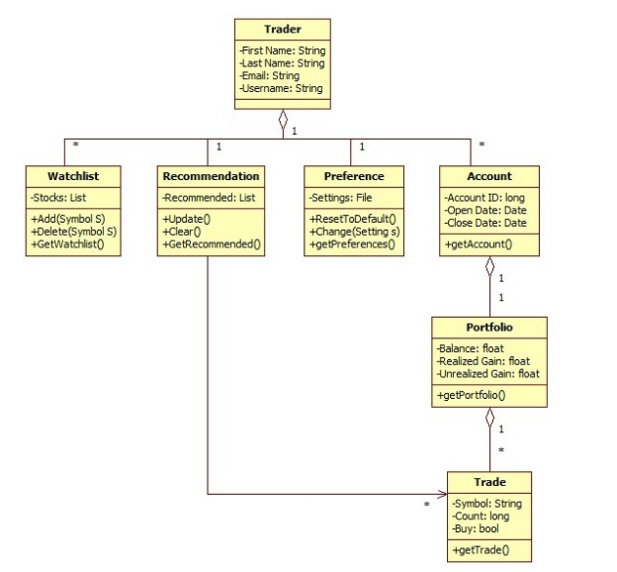

Figure 10: Class Diagram - Main
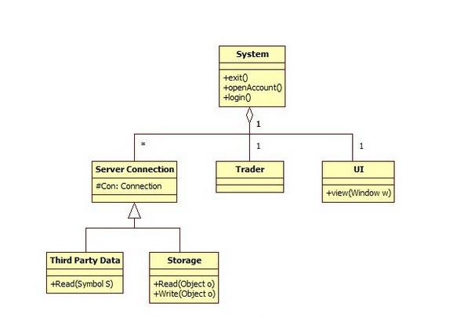
Figure 11: Class Diagram – System

3.c Dynamic Model

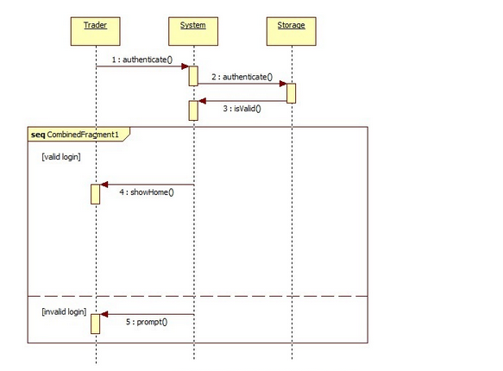

Figure 12: Sequence Diagram - Login

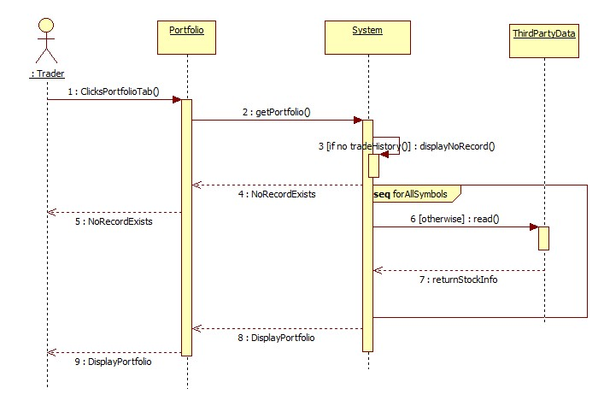
Figure 13: Sequence Diagram – View Portfolio

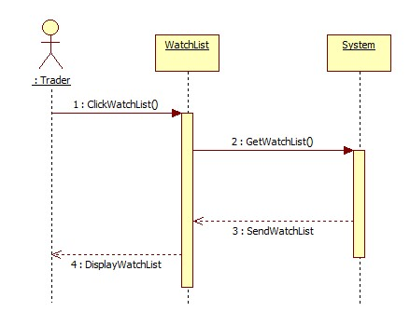
Figure 14: Scenario Diagram – View WatchList
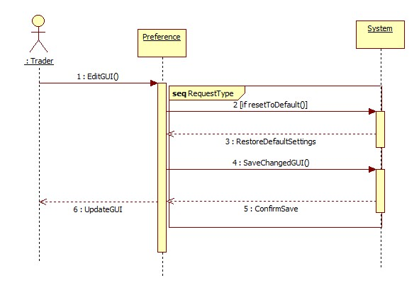
Figure 15: Scenario Diagram- EditGUI
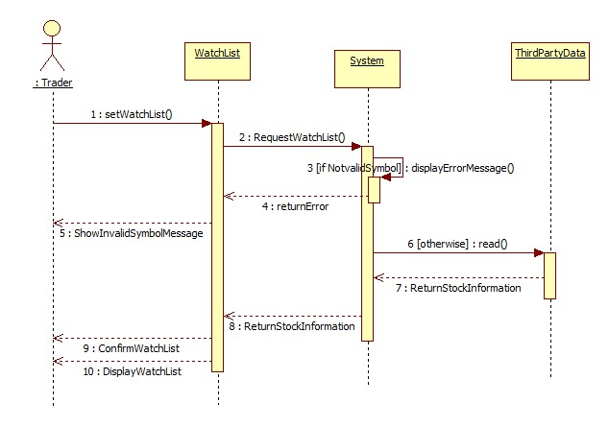
Figure 16: Sequence Diagram – SetWatchList
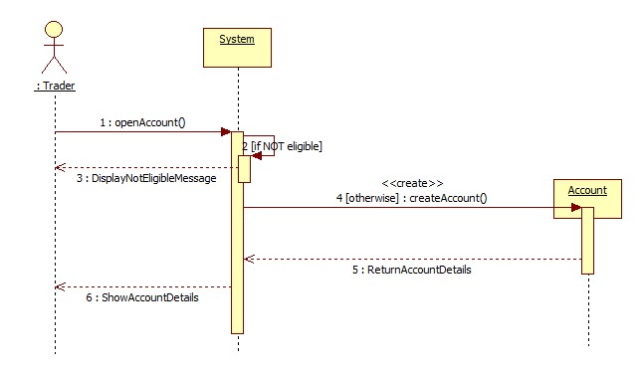
Figure 17: Sequence Diagram – OpenAccount

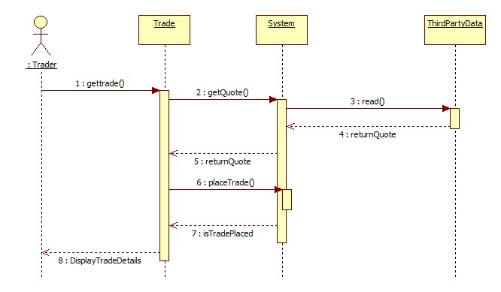
Figure 18: Sequence Diagram – PlaceTrade
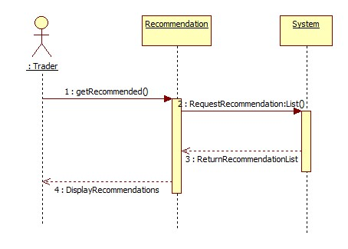
Figure 19: Sequence Diagram – GetRecommendations

3.d Subsystem Decomposition

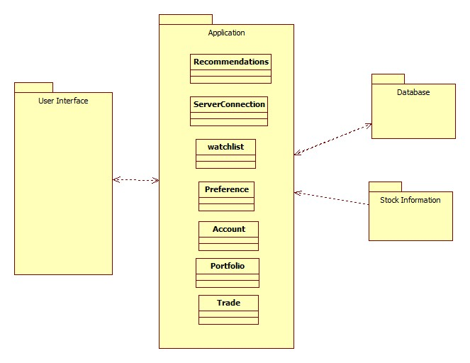

Figure 20: Subsystem Decoposition

3.e Hardware / software mapping
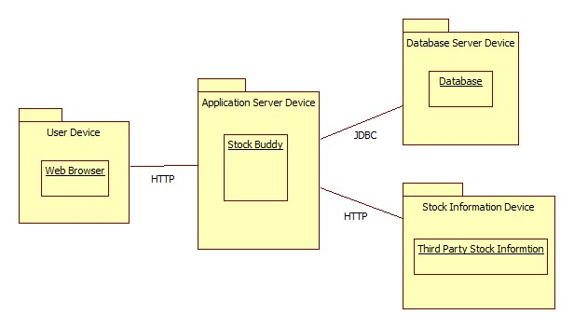
Figure 21: Hardware/Software mapping

3.f Persistent Data management
Stock Buddy keeps track of a user’s stock watch list and recommended stocks in a database hosted on a different server for security and for reliability. A couple of images used for the User Interface will also be kept on the server.
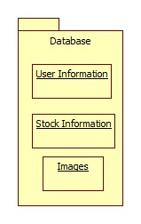
Figure 22: Persistent Data management

3.g Access control and security
Stock Buddy will make the user log in with a user name and a password. The user will be able to read and write to their information on the database. Stock Buddy will also be able to retrieve stock information from the stock information that is available online.

3.h Global software control
The control flow that we will use for Stock Buddy is event driven programming. Being that Stock Buddy will make the user input stocks he wants to tracks in order to know which stock information to pull from the online stock information and which stocks to recommend based upon the user’s stock watch list.

3.i Boundary conditions
The boundary conditions of the system specifies how the system is started, initialized, and shut down and we need to define how we deal with major failures such as data corruption and network outages.
Startup and ShutDown: On startup the user will login and Stock Buddy will retrieve their information from the database. Stock Buddy will also retrieve information for the stocks in the user’s stock watchlist from the available online stock information. Stock Buddy will also recommend any new stocks based on the user’s watchlist . If the username or password is incorrect than an error messsage will be displayed that states so. On shut down Stock Buddy will close any active connections to the database and or the online stock information. It will also save all the user’s latest data to the databse.
Exception Handling: Stock Buddy grabs the latest stock information online. In the event that the stock information is unavailable or their is no network connection available, Stock Buddy will use the most recent data from the database. In the event that the database is unavailable it will display an error message stating so. It will also do the same if both the database and online stock information is unavailable.

4. Subsystem services
User Interface:
The user interface is what the client will see. It is where he will get the latest information on his stocks and also stock recommendations. From the user interface he can also login and out of Stock Buddy.
Application:
The application subsystem is where the vast majority of the work will be done. It will pull data from the online stock information, gather the user’s information from the database, make recommendations based on the user stock watch list, and store data onto the database for later use.
Database:
The database is where we will store user’s information. Information such as his stock watch list, the latest information for the stocks that they are tracking, images to be used in the user interface, and more useful information.
Online Stock Information:
The online stock information will be where Stock Buddy pulls the latest information for our stocks in our stock watchlist. This is a third party source that will be decided upon by the team. This can be a number of different ones such as Bloomberg, Yahoo, Google, etc.

5. User Interface



Figure23: Sample UI - Login_Page
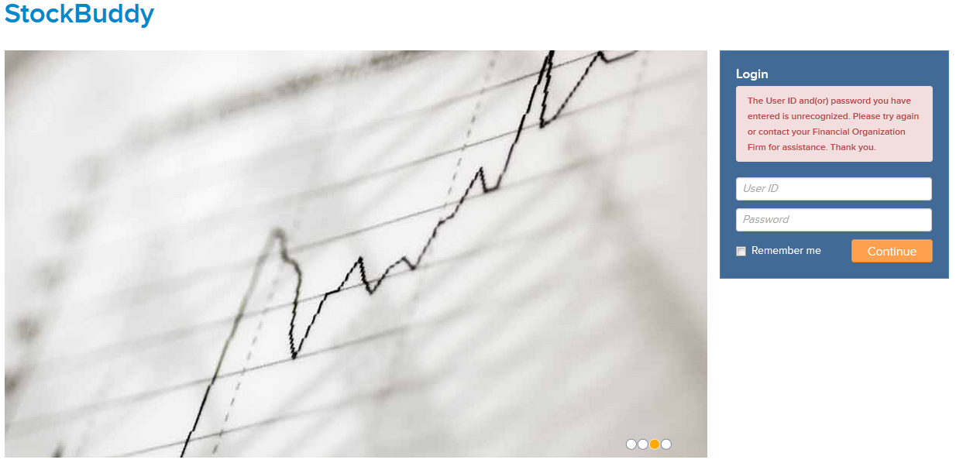
Figure 24: Sample UI - Login_Page_Failed_Login
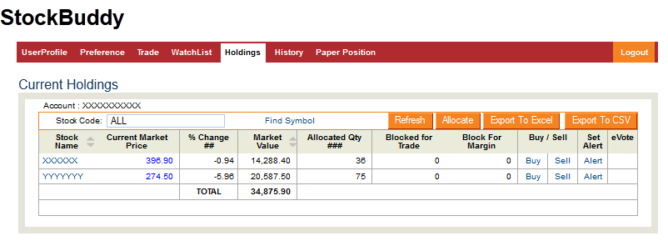
Figure 25 : Sample UI - Holdings
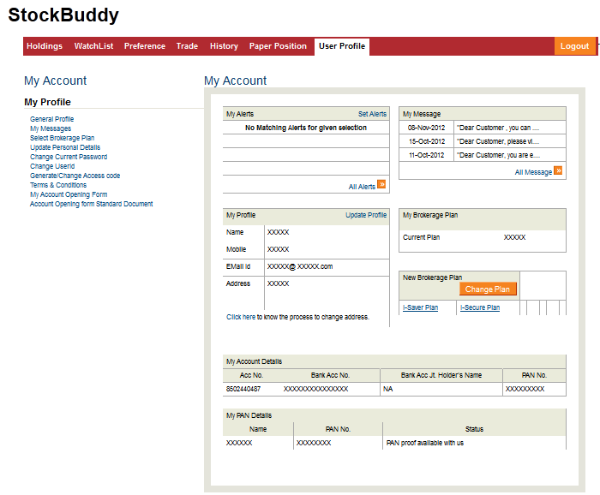
Figure 26: Sample UI - User_Profile
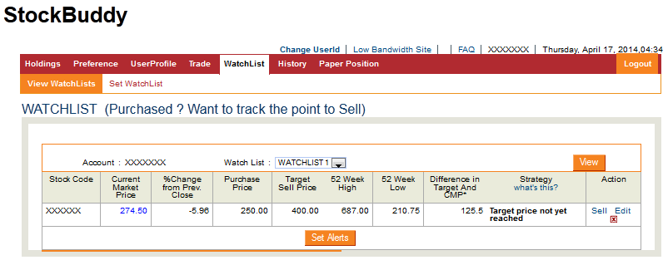
Figure 27: Sample UI - ViewWatchList
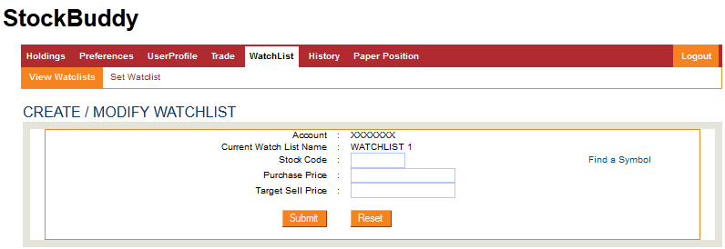
Figure 28 : Sample UI - Set_WatchList

6. Object Design

6.a Object Design trade-offs

Space vs Response Time:
The application would choose “Response Time” over “Space”. The reason is very obvious as the application needs to manipulate on real-time stock quotes and display the information to the user. Hence, space can be compromised against response time.
Buy vs Build:
The application could contract a reliable third party source to get live stock quotes. Instead of, incurring cost for building the huge database and maintaining it.

6.b Interface Documentation guidelines
The notations that must be followed for variables, methods, classes, Interfaces, packages are as follows:
Identifier Type | Rules for Naming | Examples
Package | The package name must be a noun with mixed case and with each internal words starting with a upper-case alphabet. | package
Class | The class name must be a noun with mixed case and with each internal words starting with a upper-case alphabet. | class Trader;  class Recommendation
Method | The method name must be a verb with mixed case and with first internal word starting with a lower-case alphabet. Rest of the internal words starting with a upper-case alphabet | getWatchlist();  getPreferences();
Variable | The variable name must be a noun with mixed case and with each internal words starting with a upper-case alphabet. | int Open Date;  String Email ID;

Table 3: Interface Documentation Guidelines

6.c Packages

GUI: This package consists of elements/classes related to the user interface.
Prediction: This package consists of elements related to the manipulations performed in the application.
Storage: This package consists of the elements related to the application data storage.
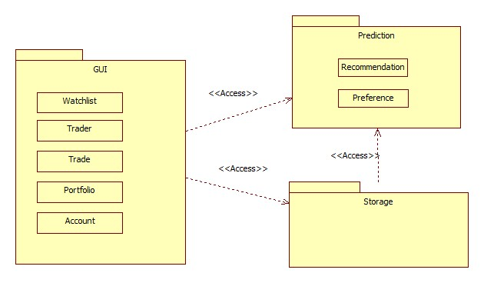

Figure 29: Package Diagram

6.d Class Interfaces

Class | Trader
Description | The Trader class deals holds the trader’s identity. It requests services from the Watchlist, Recommendation, Preference and Account class
Method(s)
  Name | Description
  initiateTrade() | The trader Initiates paper trade.
  request  Recommendation() | The trader requests for recommendation(s).
  getWatchlist | The trader retrieves the list of companies stored in the watchlist
Table 4: Class Interface - Trader

Class | Watchlist
Description | The Watchlist class gives the trader a facility to bookmark companies for future reference. It provides services to the Trader class.
Method(s)
  Name | Description
  addCompany | A trader adds a company to his/her watchlist.
  removeCompany | A trader removes a company from his/her watchlist.
  getWatchlist | A trader gets the list of companies in his/her watchlist.
Table 5: Class Interface - WatchList
Class | Recommendation
Description | This class suggest the companies depending on the trader’s history.  It provides services to the Trader class and requests services from the Trade class.
Method(s)
  Name | Description
  update  Recommendation | Updates recommendations to the trader.
  clear  Recommendation | Clears the recommendations shown to the trader.
  get  Recommendation | Requests recommendations.
Table 6: Class Interface- Recommendation
Class | Preference
Description | This class helps trader to set the preferences on the interested stocks.  It provides service to the Trader class.
Method(s)
  Name | Description
  resetToDefault | Resets the trader’s preferences to default.
  Change | Changes trader’s preferences.
  getPreferences | Retrieves trader’s preferences
Table 7: Class Interface - Prefernce
Class | Portfolio
Description | This class deals with the holding of the trader. It requests services from the Trade class and provides services to the Trader class.
Method(s)
  Name | Description
  getPortfolio | Gets the complete portfolio of the trader.
  updatePortfolio | updates portfolio with the every new trade.
Table 8: Class Interface – Portfolio

Class | Trade
Description | This class is responsible for managing paper trade. It provides services to the Trader class and the TradeHistory class.
Method(s)
  Name | Description
  placeTrade | Places the trade initiated by the trader.
  cancelTrade | Cancels the already placed trade.
  distributeTrade  Info | Distributes the trade info to maintain portfolio and trade history.
Table 9: Class Interface – Trade

Class | Account
Description | This class is responsible for mantaining th trader account information. It requests services from the Trade class.
Method(s)
  Name | Description
  getAccount | Provides the account information of the trader.
Table 10: Class Interface - Account

IV Test Plans

1 Features to be tested / not to be tested
i) Paper Account.
ii) Login.
iii) Stocks watch list.
iv) Real time Stock Quote.
v) Paper Trade.
vii) Stock Recommendations.
viii) Holdings.

2 Pass/Fail Criteria
Unit Test:
* All of the test cases must be fail safe.
* 99% of the test cases must pass.
Integration test:
* 90% of the test cases must pass with the expected output.
* All the high priority bugs related to the core functionality must be fixed before
the release.
System testing:
* 100% success of the test cases related to the functional requirements must be achieved.

3 Approach

i) Unit testing - It tests a use case or set of use cases forming the smallest unit of the system.
ii) Integration testing - The approach followed is “top-down testing strategy”. This approach test the top layer components first i.e user interface components and then integrates the components of next lower layers like middleware and database incrementally and tests it together.
iii) System testing - It ensures the verification and validation of whole system as a single unit. It checks the product against functional and non-functional requirements.

iv) Inspection testing - Peer review needs to be done for core functional classes/methods.

4 Suspension and resumption

The testing must stop on identifying an “show stopper” during integration testing and must be resumed once the issue is fixed.

5 Testing materials ( hardware / software requirements )

1. Hardware Requirements:
2. Any Personal Computer / Laptop that meets the below software requirements .
3. Software Requirements:
    - Operating system - Windows/ Unix/ IOS .
    - Browser - Internet explorer / Google chrome / Opera / Mozilla firefox.

6 Test cases
Unit Testing:

Test  case# | Test case name | Execution Steps | Expected result
1 | Open Paper Account | Preconditions:  1) The user has a unique Id provided by the brokerage firm.  Steps:  1) Visit StockBuddy wesite.  2) Sign up using the unique Id given by the brokerage firm.  3) Enter the desired user name, password  4) Submit the entered information. | Must display “Account  Successfully created”  on the screen.
2 | Login | Precondition:  1) The user has already signed up.  Steps:  1) Enter the user name and password.  2) Click Submit button. | Must display main  window of the  application upon  successful login.
3 | Get Real Time Stock Quote | Precondition:  1) The user has already logged in.  Steps:  1) Enter a company name  Example: Google.  2) Submit the request | Must display the  Google’s stock  details.
4 | Add to the Watchlist | Precondition:  1) The user has already logged in.  Steps:  1) Go to “watchlist” tab in the main window.  2) Click on “set watchlist” sub  tab.  3) Enter a company name.  4) Click on “Save” button | Must display “Added  successfully to the  watchlist”.
5 | Initiate Paper Trade | Precondition:  1) The user has already logged in.  Steps:  1) Go to the “Trade” tab in the main window.  2) Enter a company name, select the number of stocks.  3) Submit the paper trade. | Must display “Trade  was successful “ .
6 | Get Watchlists | Precondition:  1) The user has already logged in.  2) Atleast one company is added to the watchlist.  Steps:  1) Go to “watchlist” tab in the main window.  2) Click on “view watchlist” sub tab. | Must display the list of  companies added to  the watchlist.
7 | Get Stock  Recommendations | Precondition:  1) The user has already logged in.  2) Atleast one paper trade is done.  Steps:  1) Go to the “Stock  Recommendations” tab. | Must display the list of  recommended  companies.  Example: google,  yahoo and its stock details etc
8 | Get Holdings | Precondition:  1) The user has already logged in.  2) Atleast one paper trade is done.  Steps:  1) Go to the “Holdings ” tab. | Must display the list of  owned stocks.

Table 11 : Unit Testing

Integration Testing:

Test  case# | Test case name | Execution Steps | Expected result
9 | Open Paper Account  and Login | Preconditions:  1) The user has a unique Id provided by the brokerage firm.  Steps:  1) Visit StockBuddy website.  2) Sign up using the unique  Id given by the brokerage firm.  3) Enter the desired user name, password and additional information.  4) Submit the entered information.  5) Enter the user name and password.  6) Click Submit button. | Must display the  main window of the  application.
10 | Get Real Time Stock  Quote and Add to the  Watchlist | Precondition:  1) The user has already logged in.  Steps:  1) Enter a company name  Example: Google.  2) Submit the request.  3) Go to “watchlist” tab in the main window.  4) Click on “set watchlist” sub tab.  5) Enter a company name.  6) Click on “Save” button | Must display the  details of the  company the user has  requested.
11 | Get Real Time Stock  Quote, Add to the  Watchlist and Get  Watchlists | Precondition:  1) The user has already logged in.  Steps:  1) Enter a company name  Example: Google.  2) Submit the request.  3) Go to “watchlist” tab in the main window.  4) Click on “set watchlist” sub tab.  5) Enter a company name.  6) Click on “Save” button  7) Go to “watchlist” tab in the main window.  8) Click on “view  watchlist” sub tab. | Must display stock  data of a company  and then the watchlist .
12 | Initiate Paper Trade and Get Paper Positions | Precondition:  1) The user has already logged in.  Steps:  1) Go to the “Trade” tab in the main window.  2) Enter a company name, select the number of stocks.  3) Submit the paper trade.  4) Go to the “Holdings ”  tab. | Must list the paper positions of the user.
13 | Initiate Paper Trade, Get Paper Positions and Get Stock  Recommendations | Precondition:  1) The user has already logged in.  Steps:  1) Go to the “Trade” tab in the main window.  2) Enter a company name, select the number of stocks.  3) Submit the paper trade.  4) Go to the “Holdings ”  tab.  5) Go to the “Stock  Recommendations” tab. | Must display paper  positions and stock  recommendations.

Table 12 : Integration Testing

System Testing:

Test  case# | Test case Description | Execution Steps | Expected result
15 | Open Paper Account , Login, Get Real Time Stock Quote, Add to the Watchlist and Get Watchlists | Preconditions:  1) The user has a unique Id provided by the brokerage firm.  Steps:  1) Visit StockBuddy website.  2) Sign up using the unique  Id given by the brokerage firm.  3) Enter the desired user name, password and additional information.  4) Submit the entered information.  5) Again enter the user name and password.  6) Click Submit button.  7) Enter a company name  Example: Google.  8) Submit the request.  9) Go to “watchlist” tab in the main window.  10) Click on “set watchlist” sub tab.  11) Enter a company name.  12) Click on “Save” button  13) Go to “watchlist” tab in  the main window.  14) Click on “view  watchlist” sub tab. | Must display stock information of a  particular company  and watchlist
16 | Open Paper Account , Login, Initiate Paper  Trade, Get Paper  Positions and Get Stock  Recommendations | Preconditions:  1) The user has a unique Id provided by the brokerage firm.  Steps:  1) Visit StockBuddy website.  2) Sign up using the unique  Id given by the brokerage firm.  3) Enter the desired user name, password and additional information.  4) Submit the entered information.  5) Enter user name and password.  6) Click Submit button.  7) Go to the “Trade” tab in the main window.  8) Enter a company name, select the number of stocks.  9) Submit the paper trade.  10) Go to the Holdings” tab.  11) Go to the “Stock  Recommendations” tab. | Must list down the  paper positions  and stock  recommendations

Table 13: System Testing

7 Testing schedule

Week(s) | Test Type | Date(s) | Test Case(s)
4th - 12th week | Unit Testing and Integration Testing | 09/15/2014 - 11/14/2014 | Test case #1 through Test case #13
13th - 14th week | System Testing | 11/17/2014 - 11/21/2014 | Test case #14 and Test case #15
14th week | Inspection testing | 11/24/2014 - 11/28/2014 | -

Table 14 : Testing Schedule

V Project Issues

1 Open Issues

- We have still not decided what database we are going to use. We have several choices to choose from and we will further research them to decide which one fits our needs best.
- The third party stock resource which will provide us with the stock information has also yet to be decided. We have several to choose from and will further research them to see which one provides us with what we need.

2 Off-the-Shelf Solutions

2.a Ready-Made Products
- For databases we can choose from SQL, Oracle, and Microsoft access among others. Each one having a strength and weakness.
- For our stock information we have Google Finance, Yahoo, Bloomberg and others. We will have to research them to decide which one works best for us.

2.b Reusable Components

Since this is our first product, we do not have components that could be used from previous products.

2.c Products That Can Be Copied

We can look up examples of how to use the various stock APIs so we have an idea of how to use them. Then we can build off of that to suit our needs.

3 New Problems

3.a Effects on the Current Environment

Now that our clients will have access to Stock Buddy they will no longer have to look up the stock information themselves. The product should be easy enough to use so that there is not much of a learning curve.

3.b Effects on the Installed Systems

Since Stock Buddy is a new standalone web application it neither interfere with any installed systems nor does it have to interact with any pre-existing systems.

3.c Potential User Problems

The user might already be accustomed to receiving his stock information another way. The user is not being forced to use stock buddy. Stock Buddy should offer enough incentives so the user makes the switch. Incentives like paper trades, automatically grabbing the stock information, and recommended stocks.

3.d Limitations in the Anticipated Implementation Environment That May Inhibit the New Product
Database might not be able to handle a huge volume of clients and their data.

3.e Follow-Up Problems
The only problem that we do not have a solution to at the moment is what happens when the online stock information is unavailable for an extended period of time.

4 Tasks

4.a Project Planning
This project will be developed using the traditional waterfall approach. An estimate of the time and number of developers needed for each functional requirement to be completed is listed below.

fcdvd | Time | Developers
Requirement #1 | 300 hours | 3
Requirement #2 | 350 hours | 2
Requirement #3 | 700 hours | 5
Requirement #4 | 600 hours | 7
Requirement #5 | 400 hours | 3
Requirement #6 | 300 hours | 2

Table 15 : Project Planning

4.b Planning of the Development Phases

Name | Operational Date | Operating Environment | Functional Requirements
Version 0.1 | 6 months in | In-House | 1, 2, 5, 6
Version 0.9 (beta) | 10 months in | In-House/On-Site | All
Version 1.0 (release) | 12 months in | On-Site | All

Table 16 : Development Phase Planning

5 Migration to the New Product

5.a Requirements for Migration to the New Product
The product is greenfield therefore no conversion from an old system is necessary. However, a large amount of requests to open new accounts with the product is likely. Therefore, the final release will be rolled out to select customers in different time periods to ensure that the load on the servers is exceeded.
.

5.b Data That Has to Be Modified or Translated for the New System

As the project is greenfield, no data conversion is necessary.

6 Risks

Description | Probability | Cost
Customer pushes release ahead of schedule by 1 month. | 0.75 | Developers will have to be paid overtime increasing labor cost.
Customer pushes release ahead of schedule by 2 months. | 0.70 | Developers will have to be paid overtime increasing labor cost.
Customer pushes release ahead of schedule by 4 months. | 0.25 | Developers will have to be paid overtime increasing labor cost.
A requirement will run past the time allocated to it for development. | 0.90 | Teams will have to be restructured which will cost development time.
Team developers / managers resign or otherwise cannot fulfill their duty. | 0.95 | Teams will have to be restructured which will cost development time.  New labor may need to be hired depended on severity of issue.
Product does not pass customer’s acceptance test. | 0.25 | The product will need to be partially re-developed to meet specifications.
Customer will add new features mid-development | 0.80 | Finished portions of the product may need to be re-developed. Teams may need to be restructured to address the new demand.
Table 17 : Risks

7 Costs
Monetary Costs:

- Development Kit: The Development kit units need to be bought for all the hired developers. The kit would include a notebook computer (approx. 2,000$), a developer license (99$) and the documentation (free).

- Web Server: We need to configure and build a web server to host the application and other data. This would cost approximately 1,000$.

- Test Servers: We need to have different servers for testing the application in different regions (say QA,UAT,XAT etc.) which may cost around 5000$ approximately.

- Employees: Employees need to be paid. This cost would depend on a lot of factors like employee skill, location etc.

- Copyrights: The completed application has to be copyrighted to prevent others to copied releases. This cost depends on the country’s policies where the application is developed.

- Third-Party Database: There is a need for the use of a third party database and to use it there are costs involved that may go upto 1500$ per month.

Time-based costs:

- Web Server configuration: This would take approximately a week.

- Web Server maintenance: This would be a recurring indefinite task.

- App development and deployment : This would also take 4-6 months depending on the number and skill of the developers.

8 Waiting Room

- Number of Users: The number of users that can be handled at a time could be increased to 20,000.
- Theme Selection: The user can be allowed to select a theme of his/her choice from a set of themes instead of making the system static for all the users.
- Business News: A section of the home page has to show the popular trends of the business news that is going around on that day.
- Selecting home page: The user is asked for what page to open in the login window itself and once the user is logged in, he/she is taken to that page automatically.

9 Project Retrospective

In retrospect, the development process has created a viable application that can be considered as a useful tool to enhance the facilities offered to the end users, which was a primary requirement for the organization while commissioning the team to create the application. The tool emphasizes on use of technology to reduce the difficulties the users has to come across while trading.
The Initial Phase

Coming up with an idea for an application assisting trade based on a traditional system was a challenge in itself. The application had to be easy to use as well it should be performing complex tasks.

Requirements and System Design
Every conceivable situation that could be happening in in real life are thought off and analyzing the actual usage of the application played a role in deciding these requirements. The requirements that were provided by the requirement elicitation team were carefully constructed by considering the various subsystems that would be involved in the creation of such an application and the actors that would be involved in using these subsystems.

What Worked Well
The collaboration and teamwork of all members was vital in designing an application. Even though there were differences in opinions during the project’s infancy, the team managed to get a consensus on the final product.

VI Glossary
Ask: The lowest price a seller of a stock is willing to take for a share of that given stock
Beta: The tendency of a security’s return to respond to swings in the overall market
Bid: The highest price a buyer of a stock is willing to pay for a share of that given stock
Close: The last sale price of a stock on any particular day
Dividend: A sum of money paid regularly by a company to its shareholders out of its profits
Dividend Yield: A dividend expressed as a percentage of a current share price
Earnings date: The date that a particular company will make public its financial reports for the previous quarter.
Earnings per Share (EPS): The portion of a company’s profit allocated to each outstanding share of common stock.
High: The highest price a particular stock traded for in a given day
Last: The price of the most recent trade of a particular stock.
Low: The lowest price a particular stock traded for in a given day
Open: The first sale price of a stock on any particular trading day
Market Capitalization (Market Cap): The total dollar market value of all a company’s outstanding shares
Net Change: The difference in the closing price of the previous trading day and the last price of a particular stock.
Price to Earnings (P/E): The contraction of a stock’s price to earnings ratio
Stock: The generic term for common equity securities
Stock Exchange: A market in which securities are bought and sold
Symbol: Abbreviation used to uniquely identify publicly traded shares of a particular stock on a particular stock exchange
Trader: Someone who buys and sells equities

VII References / Bibliography
[1] | Robertson and Robertson, Mastering the Requirements Process.
[2] | J. Bell, "Underwater Archaeological Survey Report Template: A Sample Document for Generating Consistent Professional Reports," Underwater Archaeological Society of Chicago, Chicago, 2012.
[3] | M. Fowler, UML Distilled, Third Edition, Boston: Pearson Education, 2004.

